**THC to CBN**



**Materials Needed:**

CBD isolate

D8/ D9 THC

Sulfur

4Å Molecular Sieves

Teflon coated stir bar

Bleach

Hydrogen peroxide 30%

Sodium Hydroxide

Dry Ice

20 L short path distillation kit

Reflux condenser

Water circulator

Rotoevaporator

Chromatography equipment

Hexanes

Ethyl acetate

Isopropanol/ ethanol

acetone

T-41

T-5/ Bentonite Clay

Silica Gel 60 or MagSil PR

Celite

Activated Charcoal

**Common websites to purchase chemicals:**

Fisher Scientific, Millipore Sigma, Spectrum Chemicals, Amazon

**Process:**

**Reaction 1:**

1. In a SPD, CBD isolate/ distillate was mixed with t-5 (15% by mass) and refluxed (180* C high vacuum (~5000 mtorr) for 3-4 hours.
2. Once the 3-4 hours have passed, cool the SPD down to 140*C. Begin pulling low vacuum (100 mtorr).
   1. Check for any discoloration (blue/green). If any, collect this fraction as heads from 145-160 *C.
   2. Collect the d8 once all the color has been removed (~165-180*C).
3. Collect and record the mass of the oil captured.
4. Send off for third party testing.
5. Recent runs of this process have yielded 85% mass conversion (1 kg in, 850 g out) and up to 90% d8 by potency.

**Reaction 2:**

1. A mixture of d8/d9 THC (1000 g, 3.18 mol, 1 equiv.) and sulfur (204.2 g, 6.37 mol, 2.0 equiv.) [Sulfur stoichiometric equivalents can range from 2-10 equivalents] were placed into two-necked round bottomed flask equipped with a Teflon coated stir bar.
   1. 20 g of 4Å Molecular sieves are added.
      1. Molecular sieves are activated by placing them into a flask under vacuum and heated to 160 °C overnight.
2. Add 3L of a high boiling solvent (bp needs to be around 130*C+).
3. The flask was equipped with a reflux condenser (set to 10 °C) and a thermocouple (see setup below).
   1. Tubing leading to a **gas trap** filled with sodium hydroxide dissolved in isopropanol or ethanol at – 78 °C. (the photo below is not correct)
4. It is heated at reflux for 4 hours. The reaction is complete when the evolution of hydrogen sulfide had ceased when the flask is cooled. Collect a small amount to check when this process happens.
5. Put the solution into a reactor.
6. Wash the solution with either: 5% bleach solution or 5% hydrogen peroxide solution, followed by a neutral brine wash.
7. Remove the bottom layer (water) from the reactor after each wash.
8. Once complete, remove the organic layer (what was the top layer during these washes) and place it into a rotoevaporatory flask.
   1. The water bath MUST be replaced with oil so you can heat it to 120 *C.
   2. Remove all solvent.
9. **STOP**. You now have crude CBN.

**Purification and Isolation of CBN oil**

1. TWO options:
   1. Distillation
      1. When the evaporation is complete put the oil back into an SPD kit.
      2. Mantle temp: 225 °C; head temp is 99 °C, hot condenser temp is 115 °C: you will be pulling the heads fraction here. Heads fraction is typically anywhere from a black fraction to a light orange fraction.
      3. Main body fraction you will collect at 240-260. Have seen the following fractions: Brown oil, Lighter brown oil, clear blood red fraction
      4. Send off for testing
      5. If higher potency is desired, you will need to run chromatography.
   2. Chromatography
      1. When the evaporation is complete add hexanes to the crude mixture.
      2. Prepare a glass fritted funnel with the following: T-5/ bentonite clay (0.5 volume of funnel), T-41 (0.25 volume of funnel), Bentonite clay (small layer on top), celite (small layer on top).
      3. Load your cannabinoid dissolved in hexane onto the funnel and pull vacuum (DCVC) until you are pulling off a light-yellow solution.
      4. Continue to clean up all black solution. Stop when you have collected all light-yellow fractions.
      5. Use acetone to clean out whatever is left on the column.
      6. KEEP these two fractions separate!!!
      7. Evaporate all solvents from the separated fractions.
      8. Send off for testing
      9. If higher potency is desired, you will need to distill.

**IMPORTANT:** Previous real time runs 30-50% mass conversion (1 kg in, 300-500g out) with CBN potency ranging from 40% CBN to 88% CBN. This new process using solvents has increased the mass conversion up to 70%+ (1 kg in, 700g+ out). There are several ways to clean up this process. Chromatography will always be the best way to clean this up. Main takeaway is that one can either distill after reaction has been washed or by dissolving oil in solvent (heptane, hexane, diethyl ether, CHLOROFORM, limonene, ethanol, isopropanol) and pushing through clays (dry column vacuum chromatography).

**Sample Calculations**

$\left(\frac{1000 g CBD}{314.15\frac{g}{mol}CBD}\right)\left(\frac{2 mol Sulfur}{1 mol CBD }\right)\left(\frac{32.07\frac{g}{mol} Sulfur}{1 mol Sulfur}\right)=$

$=204.17 g Sulfur needed for 1 kg of CBD or THC$

**Reaction Setup**



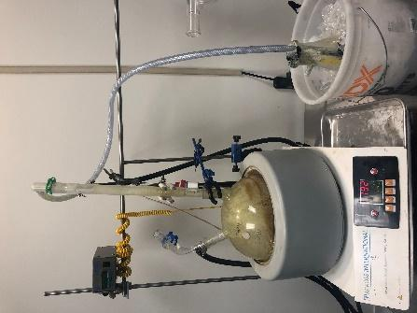 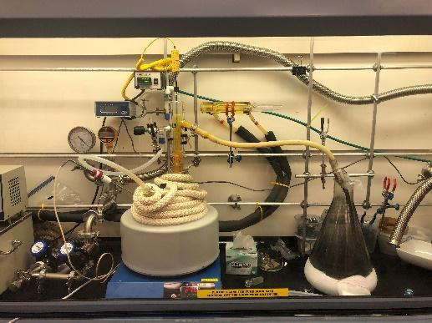 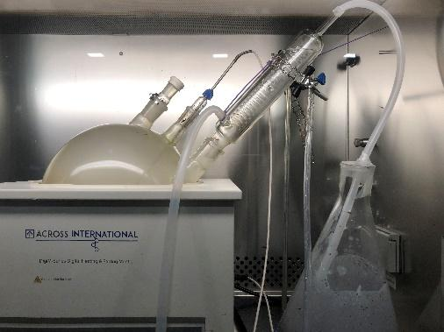

Examples of reflux setups during previous consults.

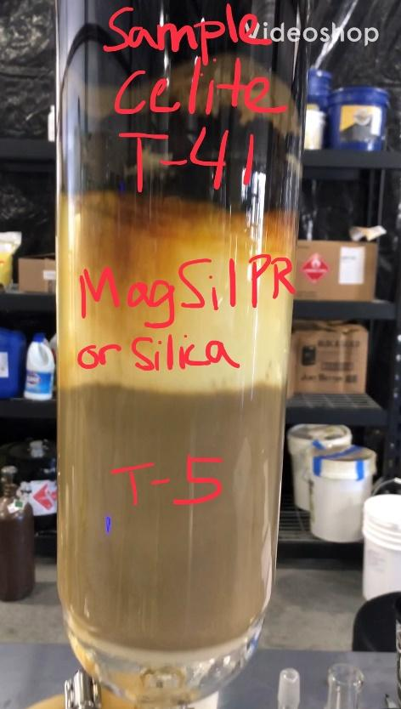

Example of how to load your glass fritted funnel

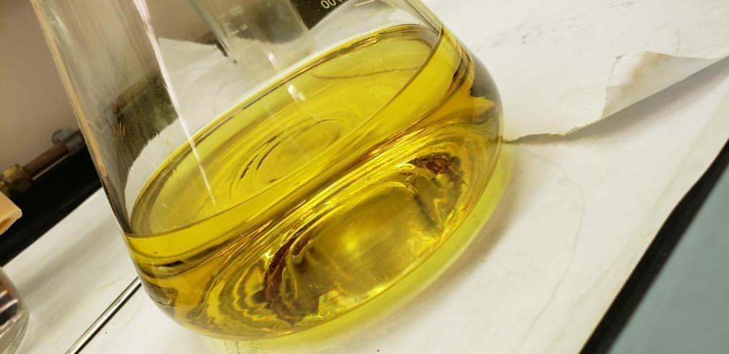 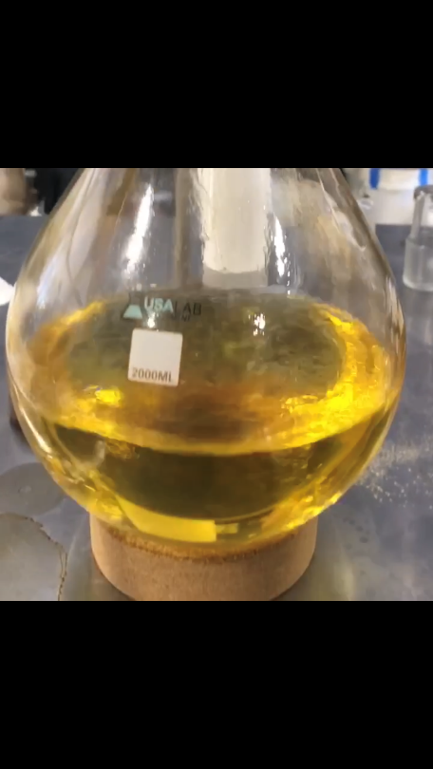

Example how your oil should look like once it is cleaned up.