Content

Simple picture 3
Technical parameters 4
Control plate 5
Production application 5
Working principle 6
Intelligent temp. controller 7
Description 7
Production feature 7
Technical parameters 7
Operation method 8
Temperature internal parameters 8
Function parameters 9
Common failures 10
Note 11
After-sale service 11

Simple picture

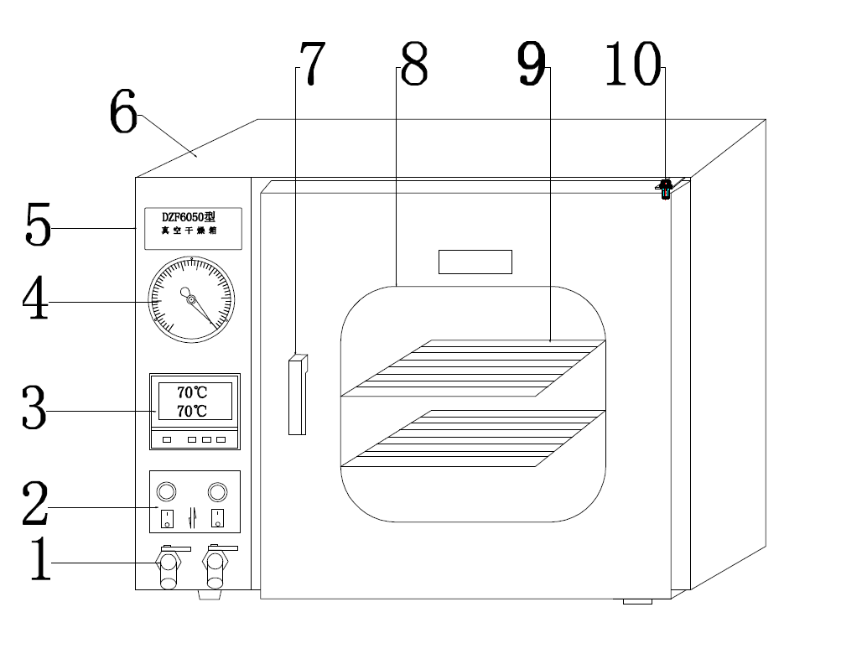
- Vacuum valve switch (air exhaust and air outlet)
- Power switch and heating switch
- Intelligent temperature control instrumentation
- Vacuum gauge
- Product name
- Oven shell
- Door handle
- Observation window
- Shelf
- Oven door hinge

Technical parameters
Model | DZF-  6010 | DZF-  6020 | DZF-  6050 | DZF-  6090 | DZF-  6210
Power supply | 220V/50Hz
Input power | 400W | 800W | 1400W | 2000W | 2400W
Temperature range | RT+10~200°C
Temp. fluctuation | 0.1°C/±1°C
Vacuum degree | 0.098MPa
Interior dimension  (mm) | 200*200*200 | 300*280*300 | 410*400*340 | 450*450*450 | 560*600  *640
External dimensions  (mm) | 600*400*430 | 620*500*480 | 720*570*540 | 770*620*710 | 730*730  *1800
Shelves | 1 Pieces |  | 2 Pieces
Optional | Explosion-proof

Control plate

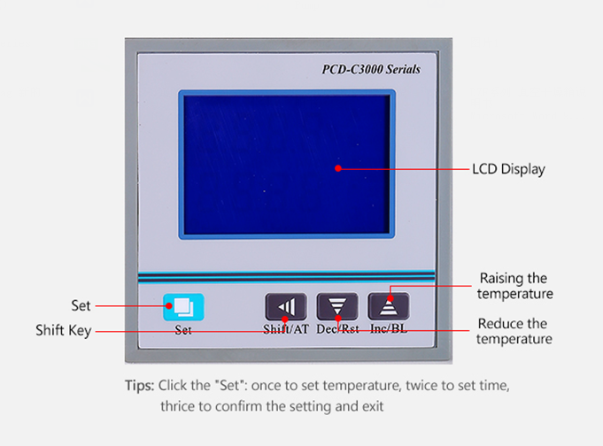

Production application
The product is suitable for teaching, scientific research, medicine, chemical industry, food and environmental protection and other fields, and drying and heat treatment of various articles under vacuum. Can do drying and heating treatment for all kinds of articles under the vacuum conditions.

Working principle
This product is used in the production of high quality steel plate or stainless steel plate, strong anti-corrosion. Bulletproof double layer temperature resistant glass observation window, make your observation work at a glance. The heat source adopts the built-in S type anti riot resistance tube, which is safe and reliable. And the honeycomb type heat conducting window enables the working space to heat evenly. The temperature controller is controlled by external high power silicon controlled, the trigger is fast, and the control is sensitive. Touch key regulator of double screen digital display panel allows you to set or more intuitive reading, the feedback value of on-off electrical signals generated by the work of the control heating element by using the built-in microcomputer processor, through the PID self tuning (manual adjustment), revised parameters will automatically lock, correct signal after processing the constant temperature in the set range, warm stamping with stable temperature error in the atmospheric and vacuum state is less than 1 DEG C +.

The front panel 'vacuum gauge' shows the vacuum degree of the studio. Before the machine is equipped with a special suction valve, the vacuum chamber air can be pumped out to carry out the vacuum drying process.

The other switch and the control device are evenly arranged on the front panel, the operation is simple and convenient, the whole cabinet has small volume, light weight, electricity saving, high thermal efficiency, and is especially suitable for the drying process of a small amount of samples.

Intelligent temp. controller

Description
The PCD-3000 temperature controller, adopt a double liquid crystal display, automatically adapt to the temperature control, no need control parameter adjustment, high control precision and no overshoot.

Production feature
External triac (heating power≦3KW)

Technical parameters
1. Display mode: LCD display;

2. Temperature measurement range: Rt+10~250℃; time setting range: 9999 minutes;

3. Display the basic error: ± 2;

4. Sensor: PT100;

5. Working environment: supply voltage: 220V ± 10%, 50HZ ± 2HZ;
Ambient temperature: 0 ~ 50 degrees ; relative humidity: < 85%RH;

Operation method
Click the setting key , enter to the temperature set state, by the increasing key , the decrease key and the shift key to set the ideal temperature. And then press the setting key, enter to the time set state. By the increasing key , the decrease key and the shift key to set the time, put the setting key again, save and exit the setting state. when the time is set to "0", there is no time setting function. When the time set is not "0", the point on the last row of the display window will display light, when the measuring temperature reaches the setting temperature, the timer begins timing,the light point will flicker. when time up, finish running,at the bottom of the display window will display "end",the buzzer will sounds for 30 seconds, you can press the increase key to reduce the sound. Press the decrease key for four seconds , the program starts running again.

Temperature internal parameters
Press the setting key about 3 seconds will show the password prompt "LC", you can modify the password is "3" by the increase key, the decrease key and the shift key, press the setting key and turn to the internal temperature parameter set state. Press the setting key can modify the parameter, and then press the setting key 3 seconds can exit this state. The parameter will be automatically saved. If no press any key within 30 seconds ,current parameter will not be saved.

Function parameters
Parameter indication | Parameter name | Parameter function instruction | (Range) factory parameter
Lc → | Password | check and modify the parameter when “Lc=3” | 0
ALH | Upper deviation temperature over alarm | When the measured temperature > the setting temperature +HAL, the alarm lamp always light and the buzzer sounds , stop the heating output. | PT100: 20.0  (0-100℃)
ALL | Lower deviation temperature over alarm | When the measured temperature < the setting temperature +HAL, the alarm lamp always light and the buzzer sounds , stop the heating output. | 0.0(0-100℃)
T | Control period | Heating control period | 5(1-60Secs)
P | Proportional band | Time ratio adjustment. Reduced P, you can speed up the heating output; increase P, can reduce the overshoot. | (8.0～50.0)  35.0
I | Integral time | Integral action regulation | 200  (1-2000Secs)
D | Differential regulation | The differential action regulation | 200  (1-2000Secs)
Pb | Zero adjustment | Modify errors measured by the sensor(low temperature),Pb= The actual temperature - the measured temperature. | (-12.0～12.0)  0. 0
PK | Full adjustment | Modify errors measured by the sensor(low temperature),PK=1000* (actual temperature - measured temperature) / measured temperature | (-999～999)  0

Common failures
Phenomenon | Causation | Solution
Without power | Socket without power supply | Replace the socket
Without power | Socket is not inserted or broken | Plug in or connect to the line.
Without power | Fuse open circuit | Replace the fuse
Without power | The power switch is not closed | Close the switch
The temperature does not rise inside the oven | The setting temperature is low | Adjust the setting temperature
The temperature does not rise inside the oven | The heater is broken | Change the heater
The temperature does not rise inside the oven | The temperature controller is broken | Change the temperature controller
The temperature does not rise inside the oven | Sensor connection loose | Adjust sensor probe position
Big error between the setting temperature and the temperature inside the oven | The temperature sensor is broken | Change the temperature sensor
 | Sensor connection loose | Adjust the sensor plug
No vacuum air pressure in vacuum chamber | Exhaust valve is not closed | Close the exhaust valve
Vacuum degree is not enough | Hose rupture or valve damage | Replace the hose or valve

If the display window display "0000", this means sensor open circuit or short circuit, please check the sensor.
Note: Please first exhaust the air in the oven before heating. When the power off, please wait the appropriate temperature in the chamber before take out of the articles .

After-sale service
1. The instruments provide one year warranty for the products described here.

2. The warranty covers part and manufacturing defects. In the case of a part or manufacturing defect, the device shall be repaired or replaced free of charge under the terms of the warranty.

3. Beyond the warranty period, product problems can also be solved by our company, but charge component cost and maintenance cost properly.

4. The instruments shall not assume liability for any damages incurred as a result of improper handling.

5. If you encounter problems when using our products, please contact us by telephone or e-mail, we will be ready to provide consulting, maintenance and other services immediately.

