Equipment Inventory

Table of Contents

Contents
Table of Contents 1
10L Glass Reactor 2
20L Glass Reactor 3
Moving Cool Air Conditioner 4
PolyScience Chiller 5
Cold Trap 6
Merlin M150 Chiller 7
Roller Mill 7
Rotary Airlock 9
Shear Mixer 10
Vibrating Screen Sifter 11

10L Glass Reactor
Images:
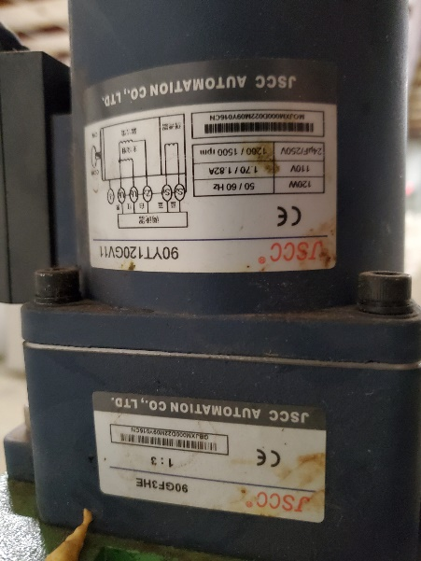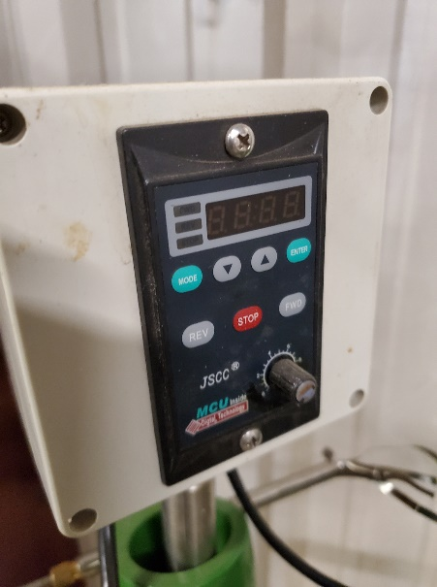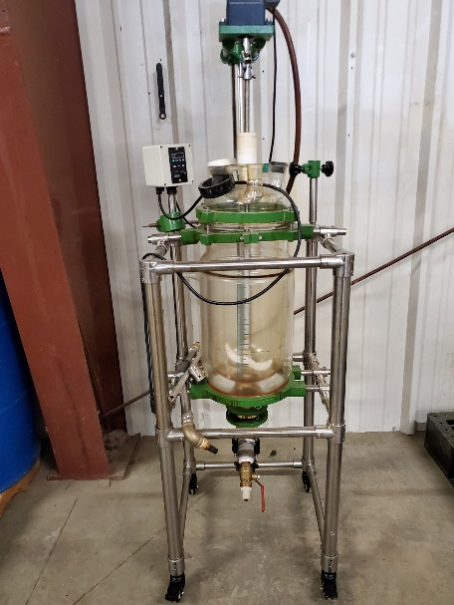

Manufacturer | N/A
Model # | N/A
Power Requirements | 120V
Dimensions | 20” x 20” x 68”

Description: Used 10L Glass Reactor, Jacketed with variable speed agitation.

20L Glass Reactor
Images:
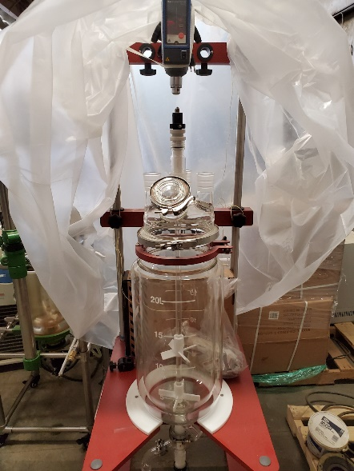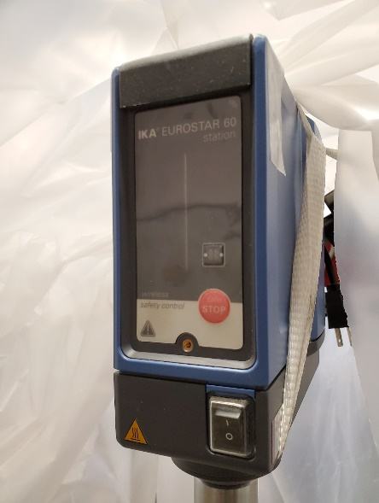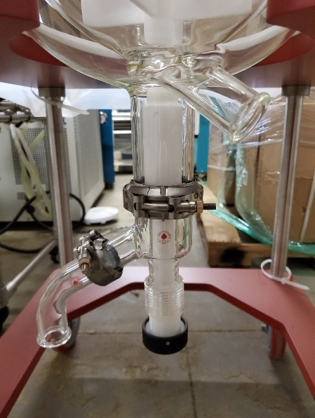

Manufacturer | N/A
Model # | N/A
Power Requirements | 120V
Dimensions | 32” x 24” x 84”

Description: New, unused, 20L Glass Reactor, Jacketed with variable speed agitation. Includes assorted fittings.

Moving Cool Air Conditioner
Images:
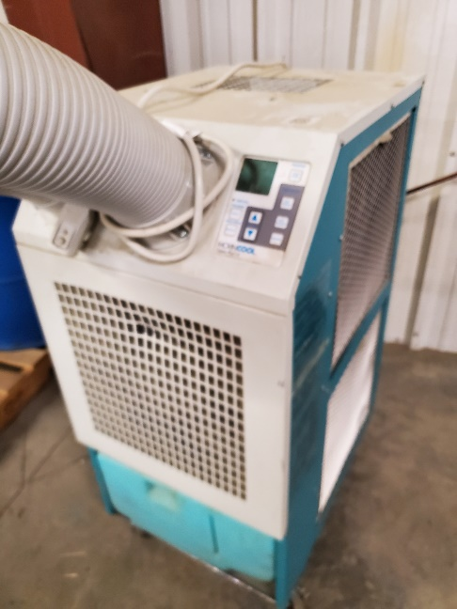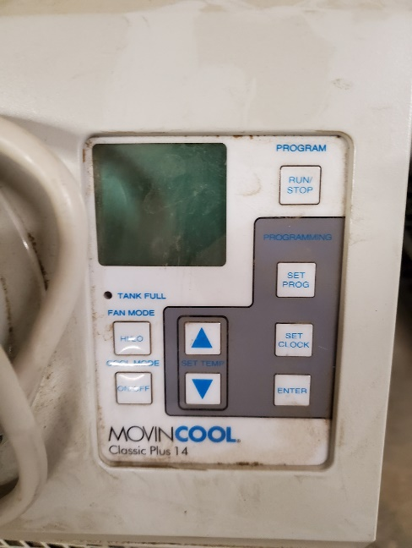

Manufacturer | N/A
Model # | N/A
Power Requirements | 120V
Dimensions | 20” x 27” x 42”

Description: USED Movin Cool Portable Air Conditioner.

PolyScience Chiller
Images:
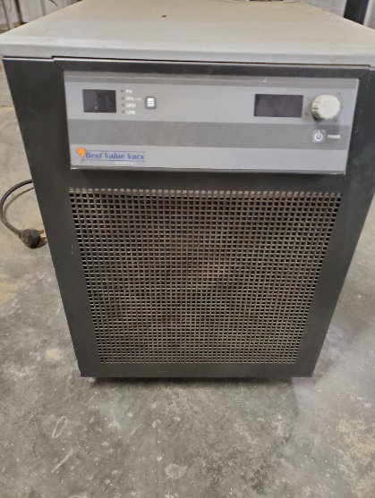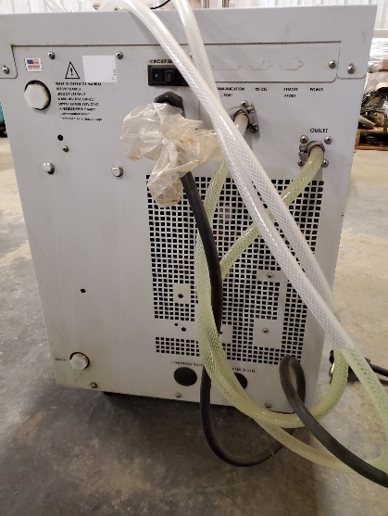

Manufacturer | PolyScience
Model # | 6860T56BV50D
Power Requirements | 240V, 30A Single Phase
Dimensions | 30” x 19” x 27”

Description: Polyscience DuraChill 1.5HP Chiller, Turbine Pump. Operating Temp 5C to 35C

Cold Trap
Images:
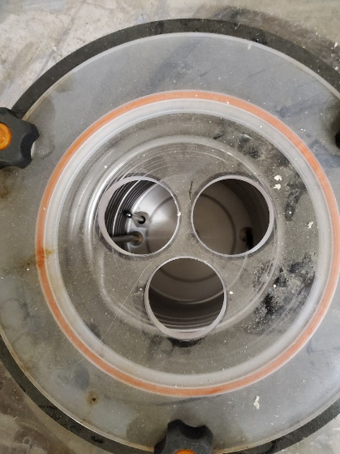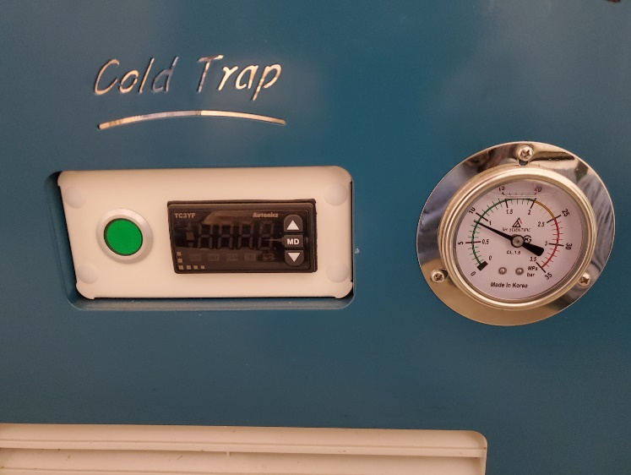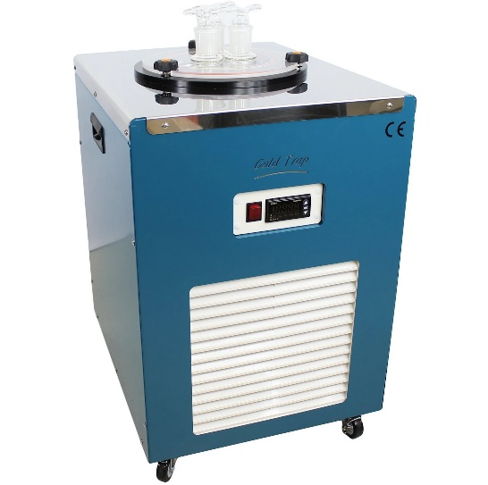

Manufacturer | BVV
Model # | CT40UL-G
Power Requirements | 120V, 10A Single Phase
Dimensions | 22” x 18” x 28”

Description: Used, Cold Trap, Low Temp Chiller. -40C

Merlin M150 Chiller
Images:
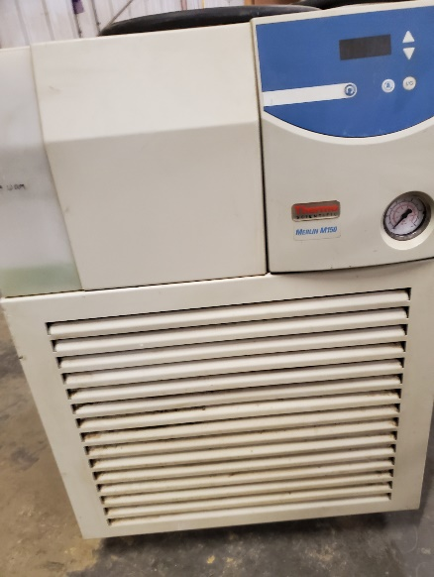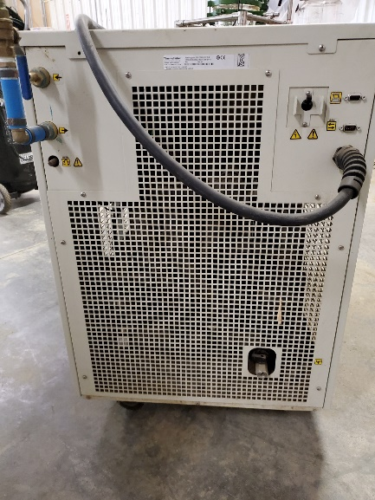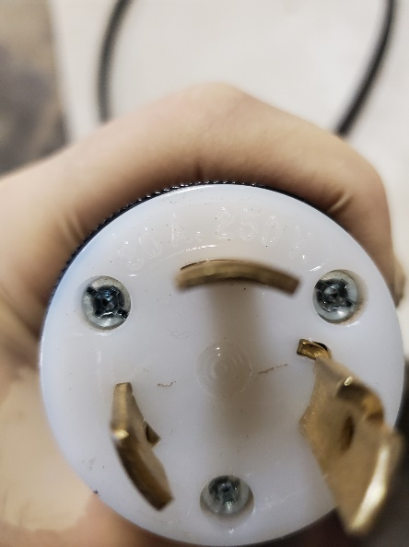

Manufacturer | ThermoFisher
Model # | Merlin M150
Power Requirements | 240V, 30A Single Phase
Dimensions | 32” x 22” x 32”

Description: Used, Merlin M150 process chiller. -20C to 35C

Roller Mill
Images:
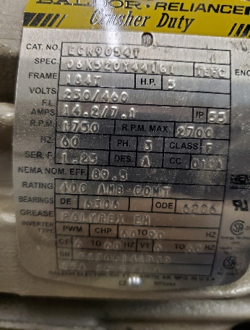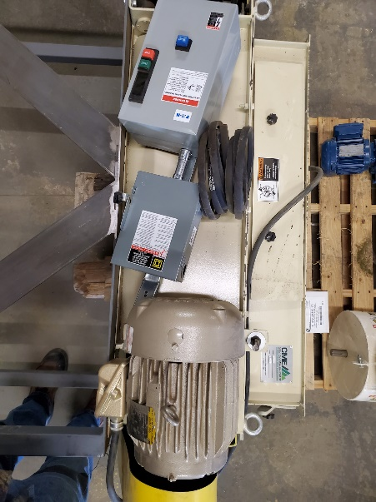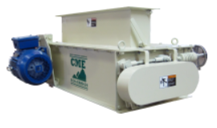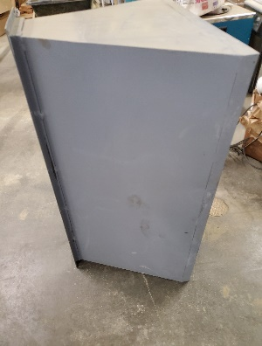

Manufacturer | Colorado Mill Equipment
Model # | CRM639
Power Requirements | 230/460V 5HP Three Phase
Dimensions | Crumbler: 57” x 21” x 38” Stand: 52” x 24” x 50” Hopper Flange: 42.5” x 8.25” Hopper: 41” x 24” x 20”

Description:USED Belt-drive design, Appx. 9 corrugations per inch, Adjustable roll gap for varying particle sizes, Low profile construction for compact installation, Full-length hinged maintenance door for roll inspection and clean-up, NEMA-approved 5HP 230/460V motor, CRM-Series Crumblers, Infeed gate adjustment, No bearing alignment required, Built in bypass. Steel Stand and Hopper included, breaker/starter.

Rotary Airlock
Images:
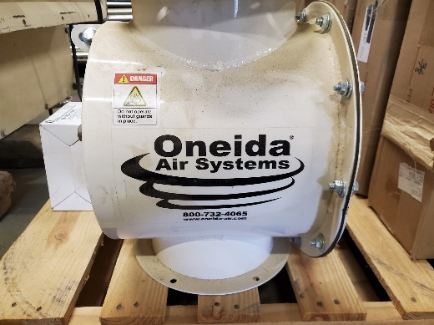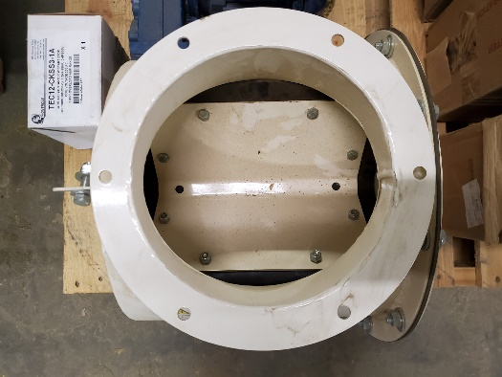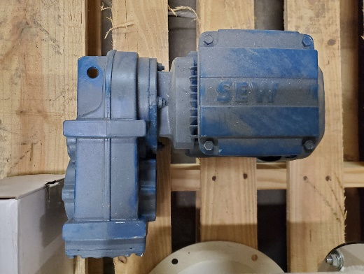

Manufacturer | Oneida Air Systems
Model # | N/A
Power Requirements | 230/460V 5HP Three Phase
Dimensions | Dimensions: 16” x 16” x 26”  Flange Dimensions: 10.5” Diameter  BIC: 9.5” 3/8” Thru x 6

Description: Unused, Rotary Air Lock. 230/460V Geared Motor. 0.25HP. Included Starter.

Shear Mixer
Images:
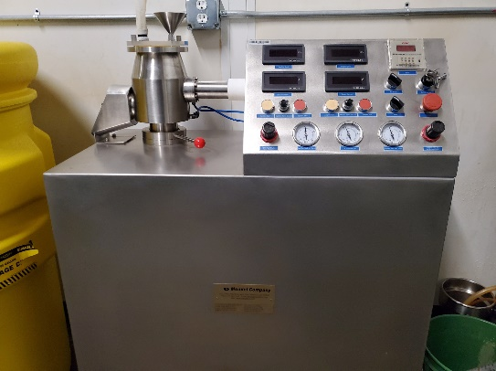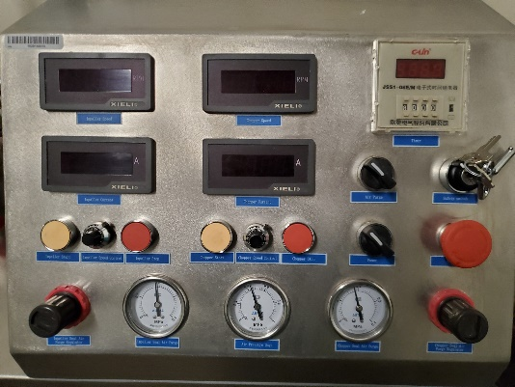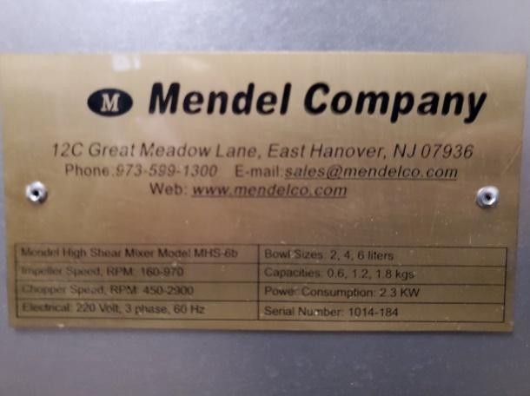

Manufacturer | Mendel Company
Model # | MHS-6b
Power Requirements | 220V, 3Phase, 60Hz
Dimensions | Dimensions 36” x 20” x 46”

Description: Used Stainless Steel High Shear Mixer. Includes three different Mixer bowl sizes (smallest shown). Pneumatic purge, variable speed control, operation timer.

Vibrating Screen Sifter
Images:
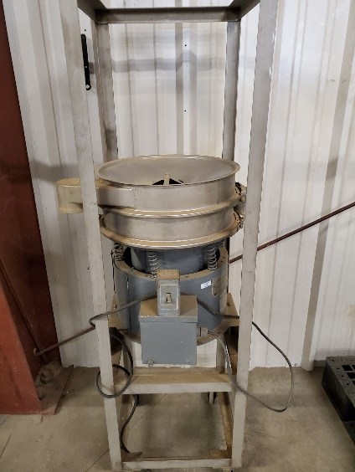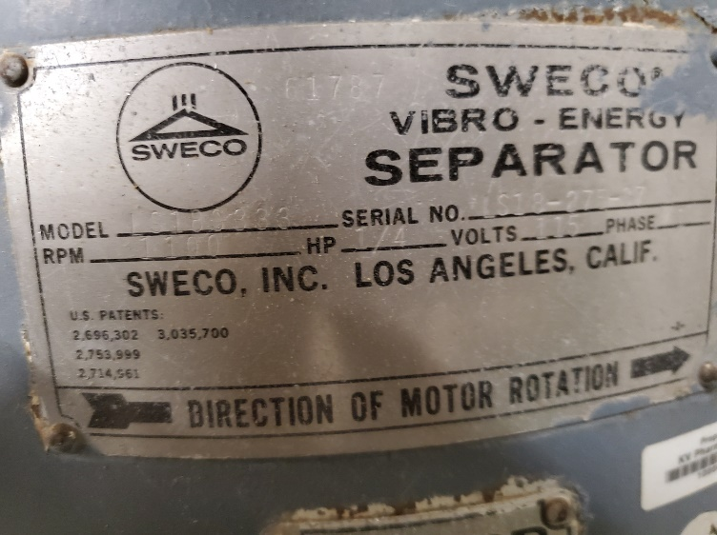

Manufacturer | Sweco
Model # | LS18S333
Power Requirements | 220V, 3Phase, 60Hz
Dimensions | Dimensions 36” x 20” x 46”

Description: Used, 1-Sweco 18” Double Deck SS Sifter, Model LS18S333, 115V. Includes extra screens.

1000L SS Tank
Images:
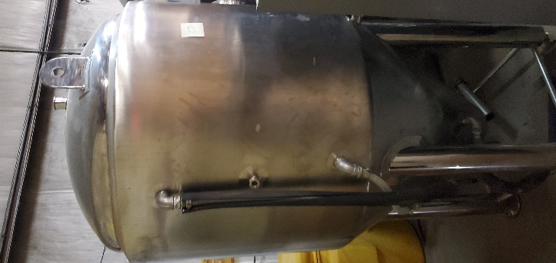

Manufacturer | Glacier Tanks
Model # | JFMU-07-BBL
Power Requirements | N/A
Dimensions | Dimensions 48” x 48” x 96”

Description: Used, 1000L (7BBL) Fermenting Tank. 304SS

20L Rotary Evaporator Heidolph
Images:
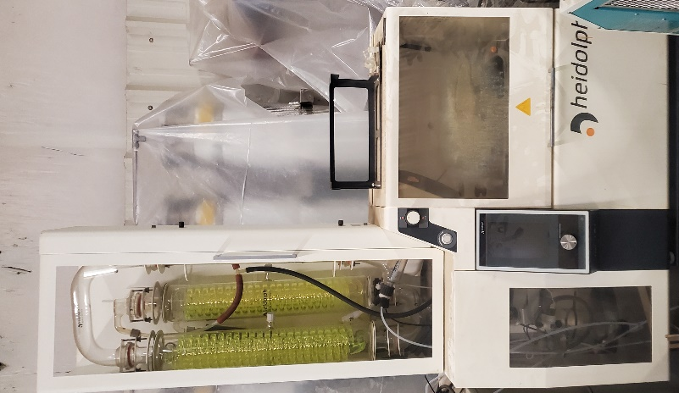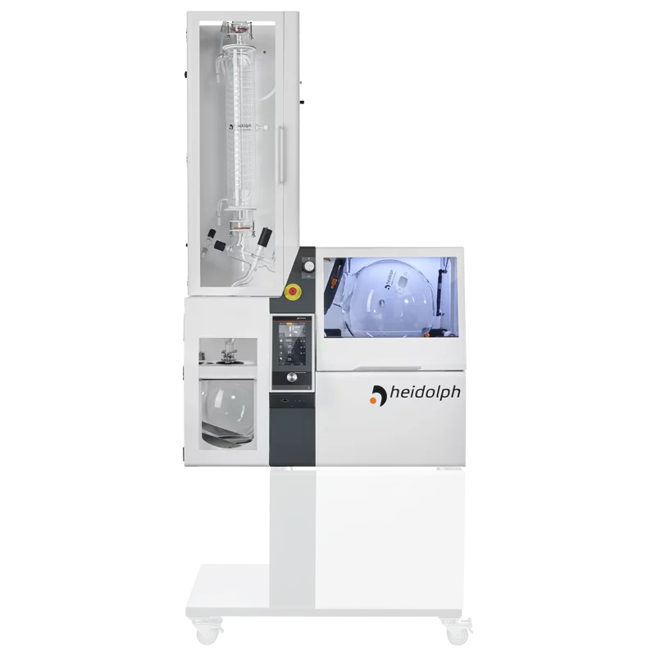

Manufacturer | Heidolph
Model # | Hei-VAP
Power Requirements | 240V/120V
Dimensions | Dimensions 36” x 60” x 72”

Description: https://heidolph-instruments.com/en/products/Large-Scale-Rotary-Evaporators/Hei-VAP-Industrial~p814

Condition: Heavily Used, Fair

Fume Hood
Images:
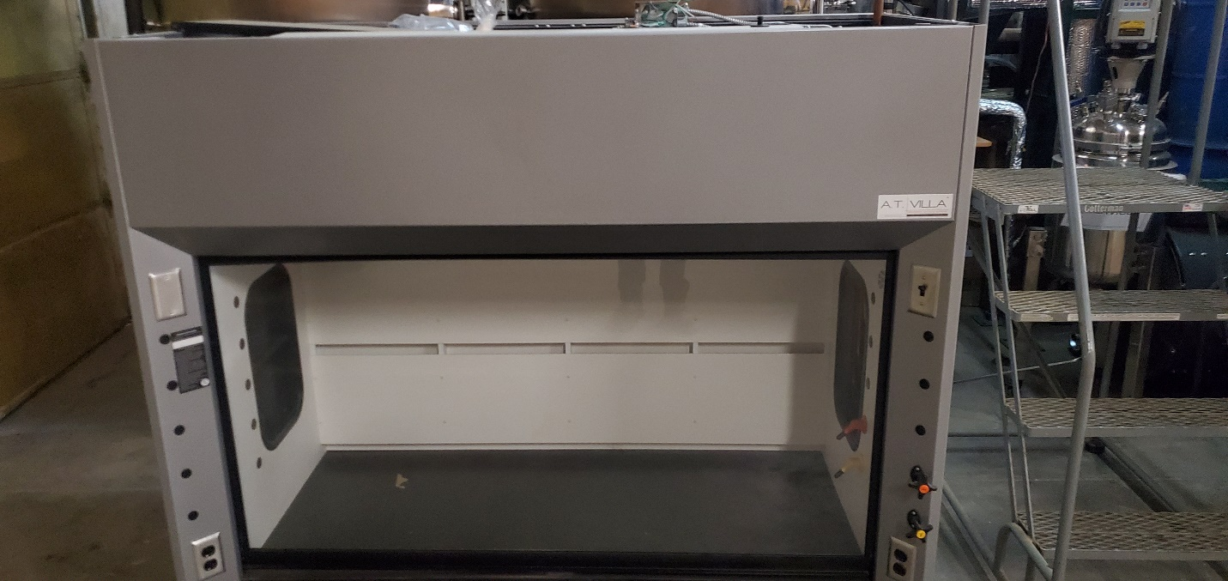

Manufacturer | N/A
Model # | N/A
Power Requirements | 120V
Dimensions | 72” x 30” x 72”

Description: Laboratory Fume Hood. Chemical Resistant Base, Counterweight Glass Shield, Gas hook ups. Base Cabinets Included.

Condition: Excellent

Variable Frequency Drive
Images:
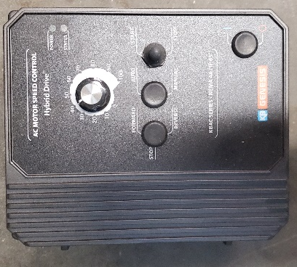

Manufacturer | KB Electronics
Model # | KBAC-48 (GRY) (9540J)
Power Requirements | Input:400/460 VAC 50/60Hz  Output: 0-460 VAC, 0-50, 60, 100, 120 Hz  Rated 8.0 Amps/Phase
Dimensions | 8” x 12” x 6”

Description: VFD 3 Phase Motor Controller.

Condition: Excellent

