Low dilution distilled HHC acetate
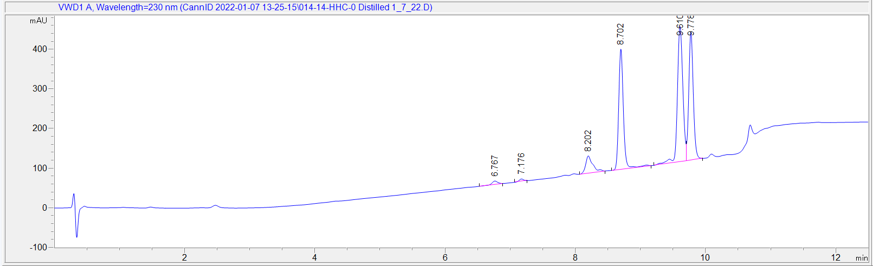
6.767 – CBD di-acetate
7.176 – CBN (unreactred)
8.202 – HHC (unreacted)
8.702 – CBN-O
9.610 – HHC-O (R)
9.778 – HHC-O (S)
CBN-O is about 10% by our calculations and the two HHC-O isomers come to around 80%. All of the peaks around HHC-O acetate are likely HHC-O isomers that when acetylated have better separation as they are not present before the acetylation procedure.

