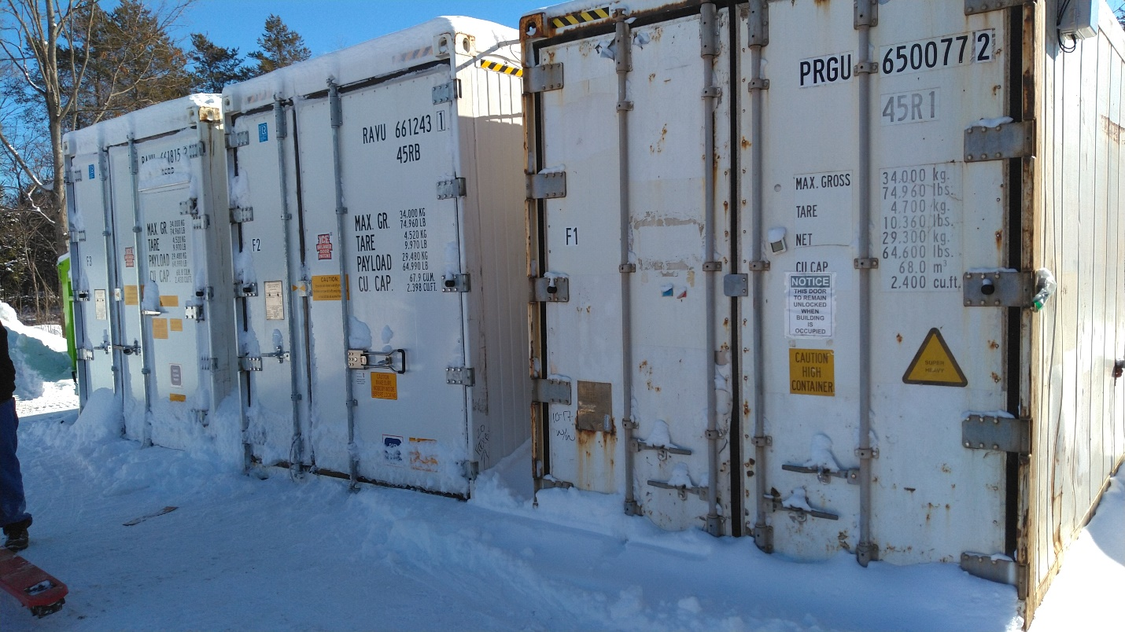
Left to Right: manu.2021(new 2022) Thermoking -40C 40’ container with personnel door, alarms, interior lighting, flat floor; manu.2020(New 2021) Thermoking -40C 40’ container with alarms, interior lighting, T-bar floor; 2004 Daikin -30C 40’ container, new comp & condenser, lots of new/upgraded parts(2021), T-bar floor.
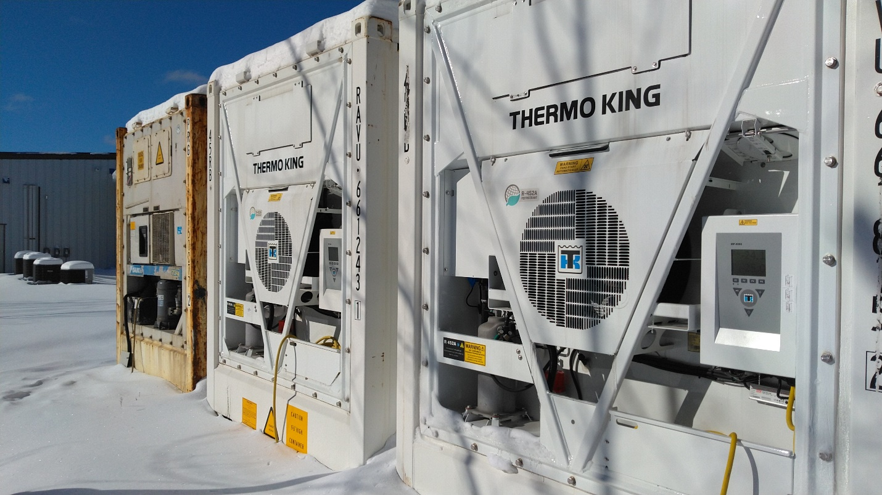
Left to right: 2004 Daikin, 2021 Thermoking, 2022 Thermoking.
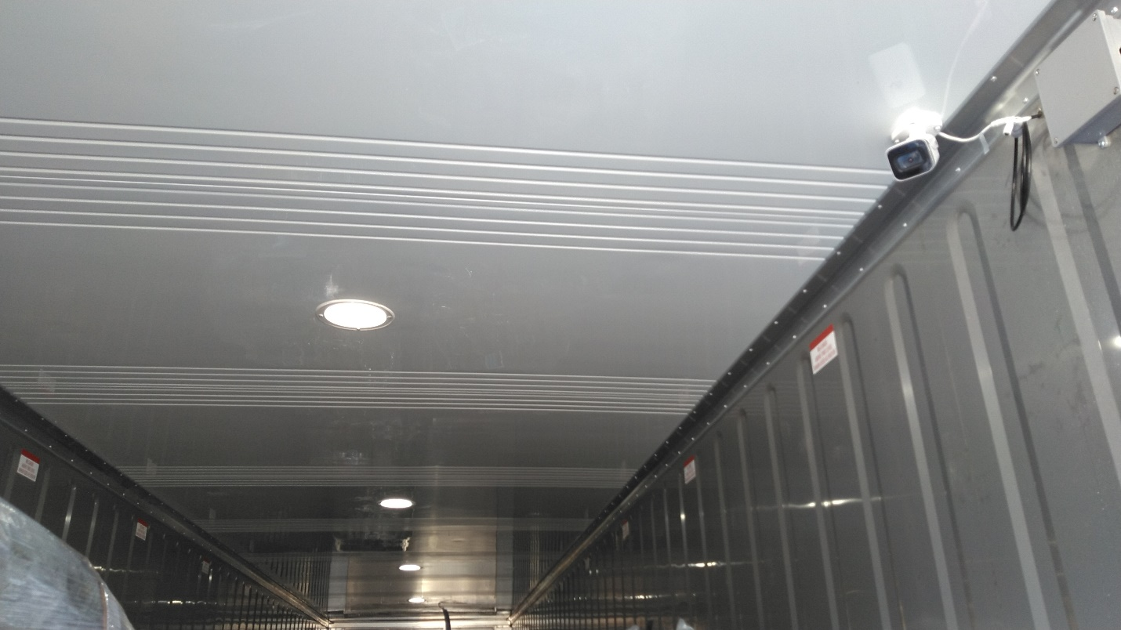
Interior LED Lighting in Thermoking units.
We have roughly 100k total into all three of these. Will entertain offers in the 75K range.
Willing to split for the right arrangement. May be able to assist with delivery.

